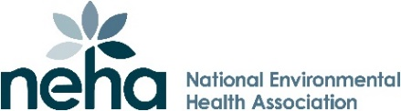

2026
WALTER F. SNYDER AWARD
Nomination Form

The Award
The Walter F. Snyder Award for Achievement of Excellence in Environmental Health is presented annually at the NEHA AEC by the National Environmental Health Association and NSF.

Nomination Procedure
- This form is all that is needed. Attach documents, testimonials and letters of support, although not required.
- Selection is primarily based on the information contained in this nomination form.
- There are 5 jurors including NSF, NEHA, PHC, NEHA President and 1 Industry Representative.
- This nomination is valid for 3 nomination periods. Nomination forms are not returned.

General Instructions
- Nomination forms must be typed. Be as specific as possible.
- Include as much information about the candidate as possible.
- Achievements you may consider obvious may not be obvious to the selection committee.
- Submit completed nomination form to Derek DeLand (ddeland@nsf.org) at NSF by May 1, 2026.
- MS Word, PDF versions of this form also available at https://www.nsf.org/about-nsf/annual-awards/snyder-award
- Please attach a CV or Bio.

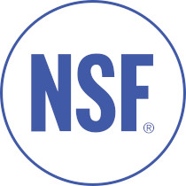
07
Date: ___________________________________

Nominee’s Name: _______________________________________________________________________
Title: ________________________________________________________________________________
Organization: _________________________________________________________________________
Organization Address: __________________________________________________________________
City: ______________________________ State: _________ Zip: _______ Country: _______________
Home Address: ________________________________________________________________________
City: ______________________________ State: _________ Zip: _______ Country: _______________
Telephone: _________________________ Email: ____________________________________________

Nominator’s Name: ______________________________________________________________________
Title: _______________________________________________________________________________
Organization: _________________________________________________________________________
Organization Address: __________________________________________________________________
City: ______________________________ State: _________ Zip: _______ Country: _______________
Telephone: _________________________ Email: ____________________________________________

How long have you known the Nominee? _____________________________________________________

In what capacities? _______________________________________________________________________

- List outstanding environmental health accomplishments that distinguish the nominee.

II. Describe the nominee’s notable contributions to public health and quality of life.

III. Describe how the nominee has demonstrated capacity to work with all interests in solving environmental health challenges.

IV. Describe the nominee’s knowledge of, and proficiency in utilizing, voluntary consensus standards to achieve environmental health objectives.

V. Outline the nominee’s leadership in securing actions on behalf of environmental health goals.

Return this completed form and any attachments by May 1, 2026 to:
Derek DeLand, Government Affairs Manager
NSF
789 Dixboro
Ann Arbor, MI 48105
Tel 734-418-6683
Email: ddeland@nsf.org
www.nsf.org

